**Topics: Descriptive Statistics and Probability**

1. Look at the data given below. Plot the data, find the outliers and find out $μ, σ, σ^{2}$

|  |  |
| --- | --- |
| **Name of company** | **Measure X** |
| Allied Signal | 24.23% |
| Bankers Trust | 25.53% |
| General Mills | 25.41% |
| ITT Industries | 24.14% |
| J.P.Morgan& Co. | 29.62% |
| Lehman Brothers | 28.25% |
| Marriott | 25.81% |
| MCI | 24.39% |
| Merrill Lynch | 40.26% |
| Microsoft | 32.95% |
| Morgan Stanley | 91.36% |
| Sun Microsystems | 25.99% |
| Travelers | 39.42% |
| US Airways | 26.71% |
| Warner-Lambert | 35.00% |

ANS:

Mean($μ$)=33.204

standard deviation($σ$)=16.404

variance($σ^{2}$)=269.09

PLOT:

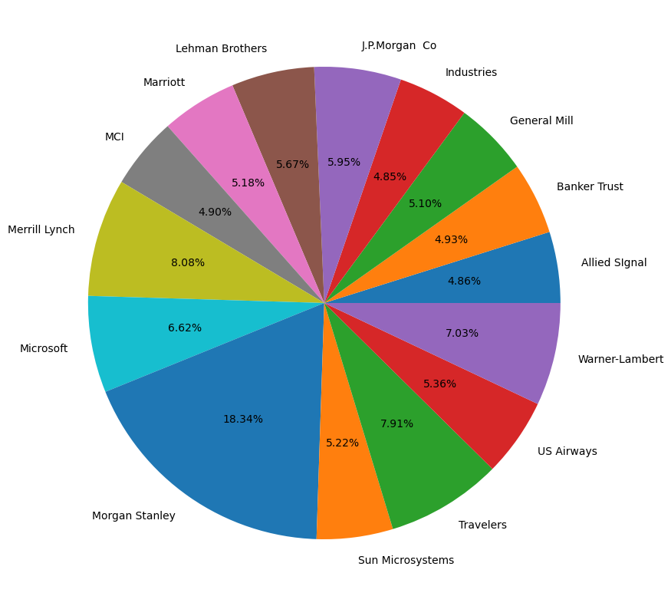



Answer the following three questions based on the box-plot above.

1. What is inter-quartile range of this dataset? (please approximate the numbers) In one line, explain what this value implies.

ANS:

The quartile range of the data set of given box plot

Q1 = 5 and Q2=12

IQR=Q2-Q1=7

1. What can we say about the skewness of this dataset?

ANS:

*The box plot data is distribution of right skewed

*Most of the data located near by Q1 .

1. If it was found that the data point with the value 25 is actually 2.5, how would the new box-plot be affected?

ANS:

*The value will be on the left side of th boxplot

*Most of the value are in right side as consider as outlier.

*The mean of 22.5 from above plot the distribution is approximate till 20.

*There is no outlier in the distribution.



Answer the following three questions based on the histogram above.

1. Where would the mode of this dataset lie?

ANS:

*The data range is approximate 5 to 7

*The histogram is bimodal distribution.

1. Comment on the skewness of the dataset.

ANS:

*The histogram data distribution is right skewed .

1. Suppose that the above histogram and the box-plot in question 2 are plotted for the same dataset. Explain how these graphs complement each other in providing information about any dataset.

ANS

*From the Q2 Boxplot and this histogram, the distribution is same ….it is same type of skewness is reflecting and the right side of skewness and right side distribution of outliers but approximately show mode as 5-7 and median around 7. So it is more compliments to both plots

1. AT&T was running commercials in 1990 aimed at luring back customers who had switched to one of the other long-distance phone service providers. One such commercial shows a businessman trying to reach Phoenix and mistakenly getting Fiji, where a half-naked native on a beach responds incomprehensibly in Polynesian. When asked about this advertisement, AT&T admitted that the portrayed incident did not actually take place but added that this was an enactment of something that “could happen.” Suppose that one in 200 long-distance telephone calls is misdirected. What is the probability that at least one in five attempted telephone calls reaches the wrong number? (Assume independence of attempts.)

ANS:

Here total calls =200,

p(success)=1/200

q(failure)=199/200

n(samples)=5

x(failure)=1

P(x)= ${{}_{}^{n}C}_{x}$ $P^{x}$ $Q^{(n-x)}$

**

P (at least 1 failure out of 5 calls) = P (1) + P (2) + P (3) + P (4) + P (5)

P (no failure calls) = P (0)

P (at least 1 failure out of 5 calls) = 1 - P (no failure calls)

= 1 - ${{}_{}^{5}C}_{0}$ ${(\frac{1}{200})}^{(0)}$ ${(\frac{199}{200})}^{(5-0)}$

**

= 1 – (1*1*0.975248)

= 0.024752.

Hence the at least 1 failure out of 5 calls =0.024752

1. Returns on a certain business venture, to the nearest $1,000, are known to follow the following probability distribution

|  |  |
| --- | --- |
| x | P(x) |
| -2,000 | 0.1 |
| -1,000 | 0.1 |
| 0 | 0.2 |
| 1000 | 0.2 |
| 2000 | 0.3 |
| 3000 | 0.1 |

1. What is the most likely monetary outcome of the business venture?

ANS:

**\*The monetary outcomes of the business venture $2000**

**\*The most probability Distribution is 0.3.**

**\*It is the most likely monetary outcome of the business venture.**

1. Is the venture likely to be successful? Explain

ANS:

\***We must compute the probability**

**\*IT is successfully positive probability**

**X= 0.2+0.2+0.3+0.1**

**X =0.8**

**venture is 80% probability to be successful.**

1. What is the long-term average earning of business ventures of this kind? Explain

ANS:

* **(1000*0.2) +(2000*0.3) +(3000*0.1) +(-2000*0.1) +(-1000*0.1)**
* **800, which clearly shows in a given period**
* **profit or loss the final outcomes returns calculated for one year**
* **The final computation of period shows the venture is having a 600 profit a month.**

1. What is the good measure of the risk involved in a venture of this kind? Compute this measure

ANS:

$\overline{X}$***= 600***

***V= (${(-2000-600)}^{2}$*0.2 + ${(-1000-600)}^{2}$*0.1 + ${(0-600)}^{2}$*0.2 + ${(1000-600)}^{2}$*0.2 + ${(2000-600)}^{2}$*0.3 + ${(3000-600)}^{2}$*0.1)/6***

***V= 2160000***

***STD= $√$ V***

***=1469.69,***